Table of Content

|  |  |
| --- | --- |
|  |  |
|  |  |
|  |  |
|  |  |
|  |  |
|  |  |
|  |  |
|  |  |
|  |  |
|  |  |
|  |  |
|  |  |
|  |  |
|  |  |
|  |  |
|  |  |
|  |  |
|  |  |
|  |  |
|  |  |
|  |  |
|  |  |
|  |  |
|  |  |
|  |  |
|  |  |
|  |  |
|  |  |
|  |  |

# INTRODUCTION

## Executive Summery

Have you ever been in the position where any of your home gadgets or furniture got broken, and you don’t know who exactly you should call to fix it, or maybe you need something to be fixed as quickly as possible, and it’s the weekend and only a few technicians are working, and you don’t know exactly how to contact them. TechFix offers a simple and efficient solution to your problems. As TechFix contains the database for plumbers, carpenters, electricians...and many many more technicians to help you fix almost anything at any time. TechFix helps you find the best technician suitable for your problem, by giving you previous feedbacks about him/her from other previous clients. TechFix also informs you about the working hours of that technician, and his/her address if you want to go to the workshop yourself.

## Document Overview

This document introduces TechFix system description and system users. It introduces system modules, system functions, system models, non-functional requirements, domain requirements and system interfaces.

## Abbreviations and Terminologies

HTML: Hypertext markup language.  
 CSS: Cascading style sheets.   
PHP: Personal home page.   
MYSQL: My structured query language.

## References

www.wikipedia.org  
 www.w3Schools.com  
 www.stackoverflow.com

# SYSTEM DESCRPTION

## Introduction

TechFix is an online solution offering technicians and services to everyone. . As TechFix contains the database for plumbers, carpenters, electricians...and many many more technicians to help you fix almost anything at any time. TechFix helps you find the best technician suitable for your problem, by giving you previous feedbacks about him/her from other previous clients. This solution should offer a great number of technicians in all fields. It will facilitate the work of both technicians and landlords. It should offer experienced technicians for different regions in a fast and safe way. TechFix can be used by everyone like landlords, housewives, employers and even technicians themselves. TechFix can be viewed on any computer, mobile or tablet. Techfix contains several functions and modules to offer the best interference and reliability between technicians and customers, also between customers and the website itself. TechFix should be considered as a helpful tool for any crises happening within your area or company. In the very soon future Techfix will prove to be efficient and successful through the feedback of customers and technicians.

## System Architecture

Tech Fix uses a Three-tier architecture. A 3-tier architecture is a type of software architecture which is composed of three “tiers” or “layers” of logical computing. They are often used in applications as a specific type of client-server system. 3-tier architectures provide many benefits for production and development environments by modularizing the user interface, business logic, and data storage layers. Doing so gives greater flexibility to development teams by allowing them to update a specific part of an application independently of the other parts. This added flexibility can improve overall time-to-market and decrease development cycle times by giving development teams the ability to replace or upgrade independent tiers without affecting the other parts of the system. The three layers are

**Presentation Tier:**The presentation tier is the front end layer in the 3-tier system and consists of the user interface. This user interface is often a graphical one accessible through a web browser or web-based application and which displays content and information useful to an end user. This tier is often built on web technologies such as HTML, JavaScript, CSS, or through other popular web development frameworks, and communicates with others layers through

API calls. This tier in TechFix is built on HTML and CSS.

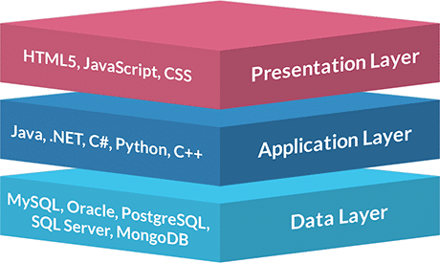   
**Application Tier:** The application tier contains the functional business logic which drives an application’s core capabilities. It’s often written in Java, .NET, C#, Python, C++,PHP ,etc.  
This layer in TechFix is written in PHP.   
**Data Tier**: The data tier comprises of the database/data storage system and data access layer. Examples of such systems are MySQL, Oracle, PostgreSQL, Microsoft SQL Server, MongoDB, etc. Data is accessed by the application layer via API calls. TechFix uses MySQl.

## System modules

TechFix System introduces a huge number of technicians to the users and many services the

contents and services to both desktop users and mobile users via the web. The system consists

of the following modules  
1. Client Area

2. Technician Area

3. Data Storage and processing  
  
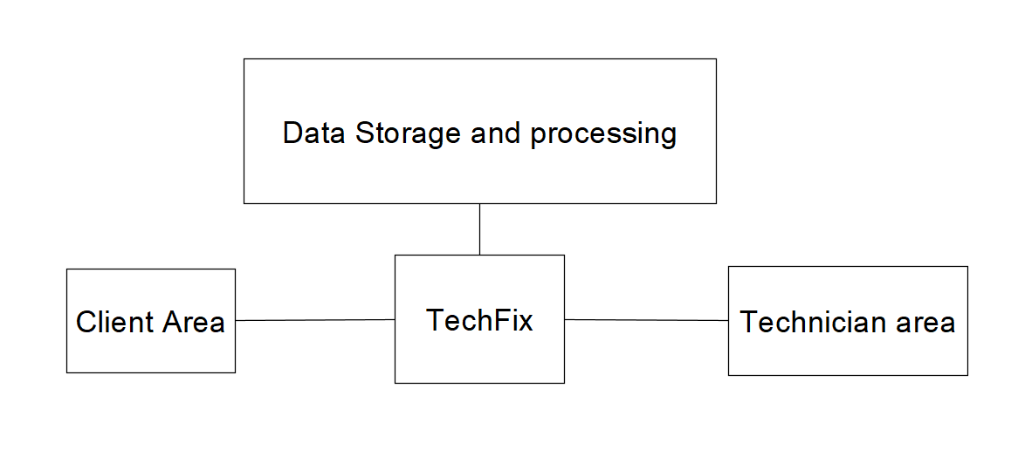

## System Users

TechFix has three types of users   
 **Client :**the normal user who can enter the site and find the technician he wants.

**Technician:**   
the technician makes an account and specify his information so that the technician can to be reached by the users.  
 **Administrator:**

The admin or the manager for the website.

# SYSTEM USERS

## Client

### Client description

Client is anyone who has a problem and wants to find an easier way to find a right technician for his/her problem like someone who need an electrician to fix a specific problem about his/her home’s electrical system or a someone who need a carpenter to repair or make something for him/her.

### Client activities

#### Create Account

The clients can create an account to participate in the site through which he can see the technicians and the type of service they provide and describe their services. The client creates an account by providing

- first name

- last Name

- email

- password

- city and region where they can find technicians closest to their area   
If a client has forgotten his/her password and he/she previously entered an email address when signing up, and you still have access to that email account, then this feature can help him/her to recover his/her access to his/her account. Just choose password reset, where you can enter either your username or your email. The system will send a temporary password to your saved email address that will allow you to retrieve your account. You can change the password after you log in.  
The system provides the clients the ability to change the password. If the client chooses to change his/her password, he/she will then be asked to enter his/her old password to confirm his/her identity, after the identity of the client is confirmed he/she are then asked to enter the new password, then save it. Once the new password is set, the old password is useless and that step of changing the password can’t be undone.

#### Search for technician

it can be done by many filters such as:

**Search by Name**

Client can search for a specific name directly, without the need for the client to scroll along the whole TechFix database for that specific name.

**Search by Location**

Because sometimes the clients need something to be fixed as fast as possible. Client can search results by location. In order for the clients to get a technician from the nearby regions to fix his/her problem as quick as possible.

**Search by Category**

Client can choose which service he/she needs and then the search will show only the technicians who provide that service between different types of technicians’ categories including (Carpenters, Plumbers, Electricians, ...etc.).

#### Write feedback

Client can write his/her feedback about the satisfaction or dissatisfaction they felt with the technician or the service. After a job is done by one of the technicians provided by TechFix, the clients are asked to provide comments, feedbacks and ratings about that technician.

#### Delete Account

Every client in the website will have the ability to deactivate and delete his/her account to which will then be deleted from TechFix databases. But that deletion is permanent and can’t be undone once the client goes through with the process.

## Technician

### Technician description

Technician is including any person who has a certain craft and wants to expand his business online by join TechFix community like

**Carpenter**

A person who makes and repairs wooden objects and structures.

**Plumber**

A person who installs and repairs the pipes and fittings of water supply, sanitation.

**Electrician**

A person who installs and maintains electrical equipment.

**Mechanic**

A person who repairs and maintains machinery.

**Craftsman**

A person skilled in creating something with a specified material.

### Technician activities

#### Creat account

Technician can create an account in order to participate in the website. Technician can sign up by providing

First name

last Name

date of birth

country and city

email

password

telephone number

fax number (If available)

name of business

type of service

description of his/her provided services

workshop address (If available)

average working hours and days

#### Add Introduction Video

The technician can provide an introductory video presenting himself/herself, which services are provided and show some of their skills and samples of his/her previous works. The video will always be shown at the technician profile for all the clients to see.

#### Manage working hours

After the technician sets his/her average working hours at the beginning when setting the account, he/she will always have the option to edit these working hours according to their needs, circumstances and national days off.

#### Delete account

Every Technician will have the ability to deactivate and delete his/her account to be deleted from TechFix databases. But that deletion is permanent and can’t be undone once the technician goes through with it.

## Administrator

### 

#### 

### 

## 

# System Functions

## Client Area Functions

### Feedback function

|  |  |
| --- | --- |
| code |  |
| Description |  |
| Input |  |
| Output |  |
| Pre-conditions |  |
| post-conditions |  |

### Client profile editing function

|  |  |
| --- | --- |
| code |  |
| Description |  |
| Input |  |
| Output |  |
| Pre-conditions |  |
| post-conditions |  |

### Search function

|  |  |
| --- | --- |
| code |  |
| Description |  |
| Input |  |
| Output |  |
| Pre-conditions |  |
| post-conditions |  |

### Delete account function

|  |  |
| --- | --- |
| code |  |
| Description |  |
| Input |  |
| Output |  |
| Pre-conditions |  |
| post-conditions |  |

## Technician Area Functions

### Technician Profile Editing Function

|  |  |
| --- | --- |
| code |  |
| Description |  |
| Input |  |
| Output |  |
| Pre-conditions |  |
| post-conditions |  |

### Add introduction video function

|  |  |
| --- | --- |
| code |  |
| Description |  |
| Input |  |
| Output |  |
| Pre-conditions |  |
| post-conditions |  |

### Delete account function

|  |  |
| --- | --- |
| code |  |
| Description |  |
| Input |  |
| Output |  |
| Pre-conditions |  |
| post-conditions |  |

# SYSTEM MODELS

## Use Case diagrams

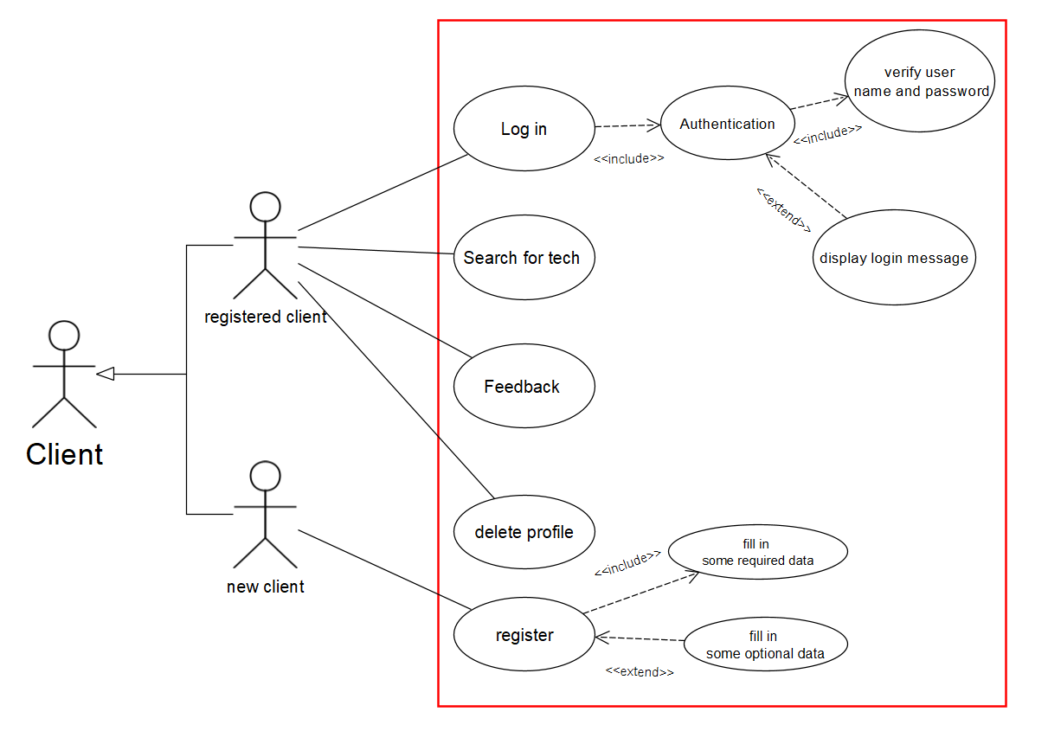

# 

# 

## Sequence Diagram

# NON-FUNCTIONAL REQUIREMENTS